

DMN Modeler Report

DT Using Variables

**Published: 7/30/2018**

**By: Edson Tirelli**

Table of Contents

Decision Table - compare values 3

Decision Requirement Diagram 3

Elements 3

# Decision Table - compare values

## Decision Requirement Diagram

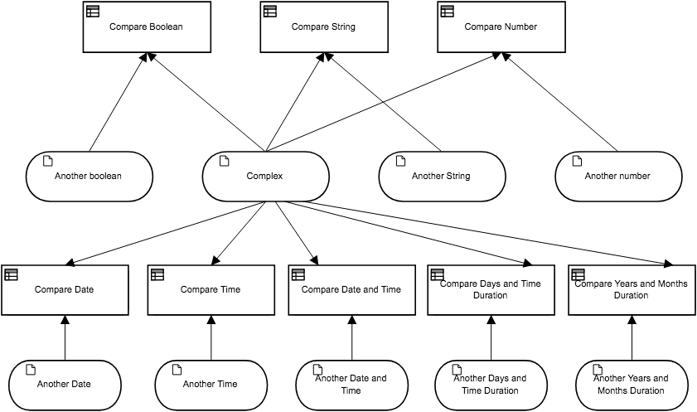

## Elements

 **Compare Boolean (Decision)**

**Output Data Type**

|  |  |
| --- | --- |
| Type | Text |

**Decision Logic (Decision Table)**

|  |  |  |
| --- | --- | --- |
| **Compare Boolean**  *Text* | | |
| U | Another boolean | | Compare Boolean |  |
| *Boolean* | | *Text* |  |
| 1 | Complex.aBoolean | | "Same boolean" |  |
| 2 | not(Complex.aBoolean) | | "Not same boolean" |  |

 **Compare String (Decision)**

**Output Data Type**

|  |  |
| --- | --- |
| Type | Text |

**Decision Logic (Decision Table)**

|  |  |  |
| --- | --- | --- |
| **Compare String**  *Text* | | |
| U | Another String | | Compare String |  |
| *Text* | | *Text* |  |
| 1 | Complex.aString | | "Same String" |  |
| 2 | not(Complex.aString) | | "Different String" |  |

 **Compare Number (Decision)**

**Output Data Type**

|  |  |
| --- | --- |
| Type | Text |

**Decision Logic (Decision Table)**

|  |  |  |
| --- | --- | --- |
| **Compare Number**  *Text* | | |
| U | Another number | | Compare Number |  |
| *Number* | | *Text* |  |
| 1 | Complex.aNumber | | "Equals" |  |
| 2 | >Complex.aNumber | | "Bigger" |  |
| 3 | < Complex.aNumber | | "Smaller" |  |

 **Another boolean (Input Data)**

**Input Data Type**

|  |  |
| --- | --- |
| Type | Boolean |

 **Complex (Input Data)**

**Input Data Type**

|  |  |
| --- | --- |
| Type | Complex |

 **Another String (Input Data)**

**Input Data Type**

|  |  |
| --- | --- |
| Type | Text |

 **Another number (Input Data)**

**Input Data Type**

|  |  |
| --- | --- |
| Type | Number |

 **Compare Date (Decision)**

**Output Data Type**

|  |  |
| --- | --- |
| Type | Text |

**Decision Logic (Decision Table)**

|  |  |  |
| --- | --- | --- |
| **Compare Date**  *Text* | | |
| U | Another Date | | Compare Date | Description |
| *Date* | | *Text* |  |
| 1 | Complex.aDate | | "Same Date" |  |
| 2 | > Complex.aDate | | "Future Date" |  |
| 3 | < Complex.aDate | | "Past Date" |  |

 **Compare Time (Decision)**

**Output Data Type**

|  |  |
| --- | --- |
| Type | Text |

**Decision Logic (Decision Table)**

|  |  |  |
| --- | --- | --- |
| **Compare Time**  *Text* | | |
| U | Another Time | | Compare Time | Description |
| *Time* | | *Text* |  |
| 1 | Complex.aTime | | "Same Time" |  |
| 2 | > Complex.aTime | | "Future Time" |  |
| 3 | < Complex.aTime | | "Past Time" |  |

 **Compare Date and Time (Decision)**

**Output Data Type**

|  |  |
| --- | --- |
| Type | Text |

**Decision Logic (Decision Table)**

|  |  |  |
| --- | --- | --- |
| **Compare Date and Time**  *Text* | | |
| U | Another Date and Time | | Compare Date and Time | Description |
| *Date and time* | | *Text* |  |
| 1 | Complex.aDateTime | | "Same date time" |  |
| 2 | > Complex.aDateTime | | "Future date time" |  |
| 3 | < Complex.aDateTime | | "Past date time" |  |

 **Compare Days and Time Duration (Decision)**

**Output Data Type**

|  |  |
| --- | --- |
| Type | Text |

**Decision Logic (Decision Table)**

|  |  |  |
| --- | --- | --- |
| **Compare Days and Time Duration**  *Text* | | |
| U | Another Days and Time Duration | | Compare Days and Time Duration | Description |
| *Days and time duration* | | *Text* |  |
| 1 | Complex.aDaysAndTimeDuration | | "Same duration" |  |
| 2 | > Complex.aDaysAndTimeDuration | | "Longer duration" |  |
| 3 | < Complex.aDaysAndTimeDuration | | "Shorter duration" |  |

 **Compare Years and Months Duration (Decision)**

**Output Data Type**

|  |  |
| --- | --- |
| Type | Text |

**Decision Logic (Decision Table)**

|  |  |  |
| --- | --- | --- |
| **Compare Years and Months Duration**  *Text* | | |
| U | Another Years and Months Duration | | Compare Years and Months Duration | Description |
| *Years and month duration* | | *Text* |  |
| 1 | Complex.aYearsAndMonthsDuration | | "Same duration" |  |
| 2 | > Complex.aYearsAndMonthsDuration | | "Longer duration" |  |
| 3 | < Complex.aYearsAndMonthsDuration | | "Shorter duration" |  |

 **Another Date (Input Data)**

**Input Data Type**

|  |  |
| --- | --- |
| Type | Date |

 **Another Time (Input Data)**

**Input Data Type**

|  |  |
| --- | --- |
| Type | Time |

 **Another Date and Time (Input Data)**

**Input Data Type**

|  |  |
| --- | --- |
| Type | Date and time |

 **Another Days and Time Duration (Input Data)**

**Input Data Type**

|  |  |
| --- | --- |
| Type | Days and time duration |

 **Another Years and Months Duration (Input Data)**

**Input Data Type**

|  |  |
| --- | --- |
| Type | Years and month duration |

**Complex**

|  |  |
| --- | --- |
| aBoolean | Boolean |
| aNumber | Number |
| aString | Text |
| aDate | Date |
| aTime | Time |
| aDateTime | Date and time |
| aDaysAndTimeDuration | Days and time duration |
| aYearsAndMonthsDuration | Years and month duration |